Ramona Drill Meet

By Amy Guerrero

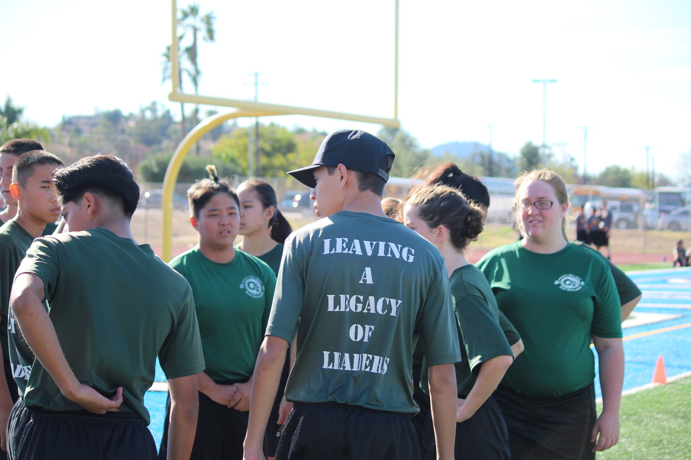

January 13, 2018, Ramona Drill Meet, an event where schools from different areas come with their drill teams to compete and, make their school name be remembered. To sit in or, be part of an event like this is crucial to becoming a competitive program. Preparing for drill meets take a lot of preparation not only for the commanders but, for the cadets as well, with long practices, motivational talks, and lots of patience. The event is divided up into multiple phases:

1. Inspection – Ram Battalion
2. Color Guard – Johnson
3. Unarmed Regulation - Oliquiano
4. Armed Regulation - Lee
5. Unarmed Exhibition - Carpenter
6. Armed Exhibition - Lee
7. Academic Team - Leon
8. PT – Ram Battalion

Color Guard led by Tristan Johnson.

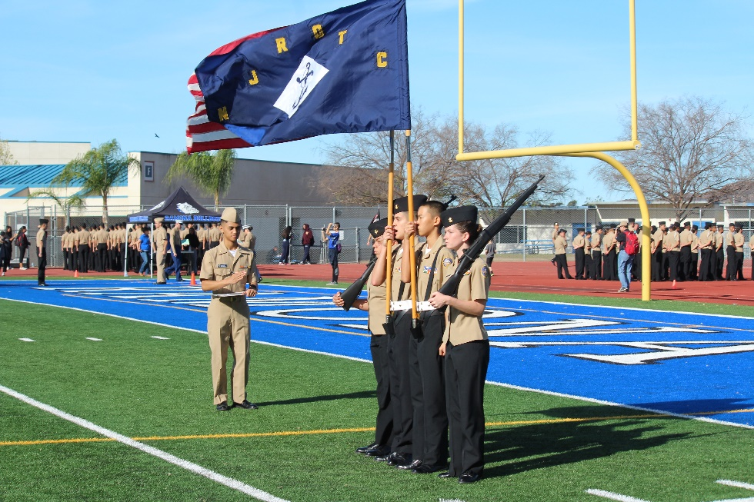

Johnson has been working hard on his team, and the routine all together, as stated, *“My entire team showed all the hard work and dedication they did during practice. The event went well. It taught us that the only way is forward, and we will get better. My team had more emotion with the competition. We all put our strength into what we did. The entire performance made me proud. I know we did our absolute best and that we’ve grown so much.”*

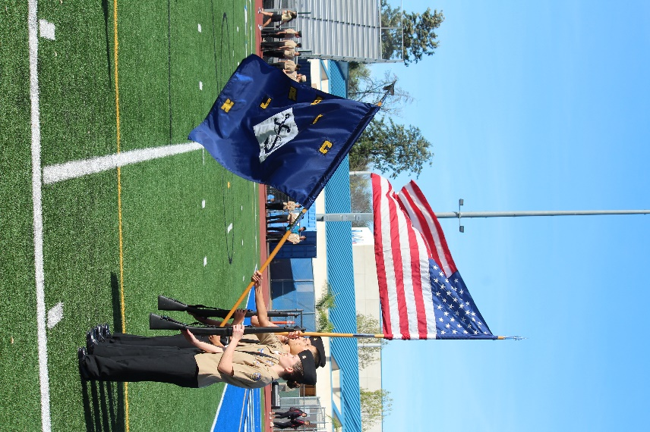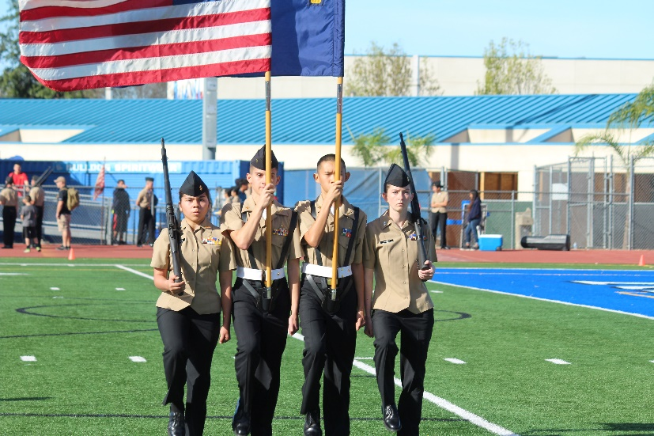

Question: What do you think made Chief and Colonel proud?

Johnson: *“Chief and Colonel were very proud of our performance. Watching our performance was the proudest moment, because they both saw that our practice was well done.”*

Led by Johnson(commander).

Unarmed Regulation placed 13th – Oliquiano.

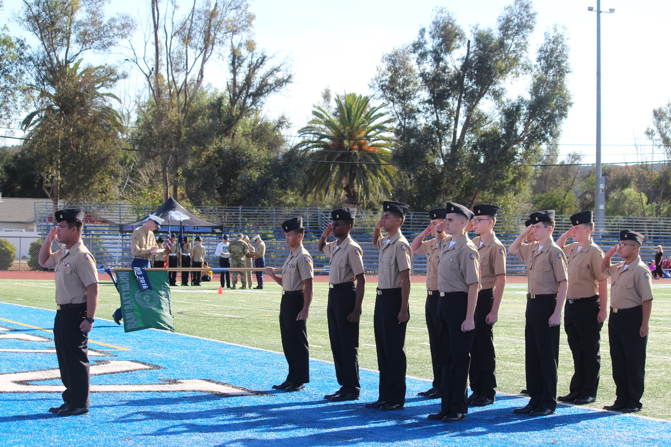

The interview with Oliquiano about his portion of the drill meet was very well thought out, with the commander having lots to say. *“I believe my team performed exponentially better compared to last year. Lining up before the drill deck, my team was calm and collected, ready to use the many hours of hard work and dedication that we spent before and after school. Movements were made sharp, and we marched on with high spirits, bolstered with the accompaniment of how well the battalion did during the inspection phase. The squad leaders, Amantine, Kunkel, and Corona, set a well-defined speed of march that everyone was able to follow with ease, and made my command calling straightforward. My proudest moment was when we completed the drill card, exiting the deck, knowing that we did our absolute best.”*

Question: What do you think made Chief and Colonel proud?

Oliquiano: *“I believe what made Chief and Colonel proud was our overall performance compared to last years, showing that we did make considerable improvements, and that we finally got the program to the state that they wanted it in.”*

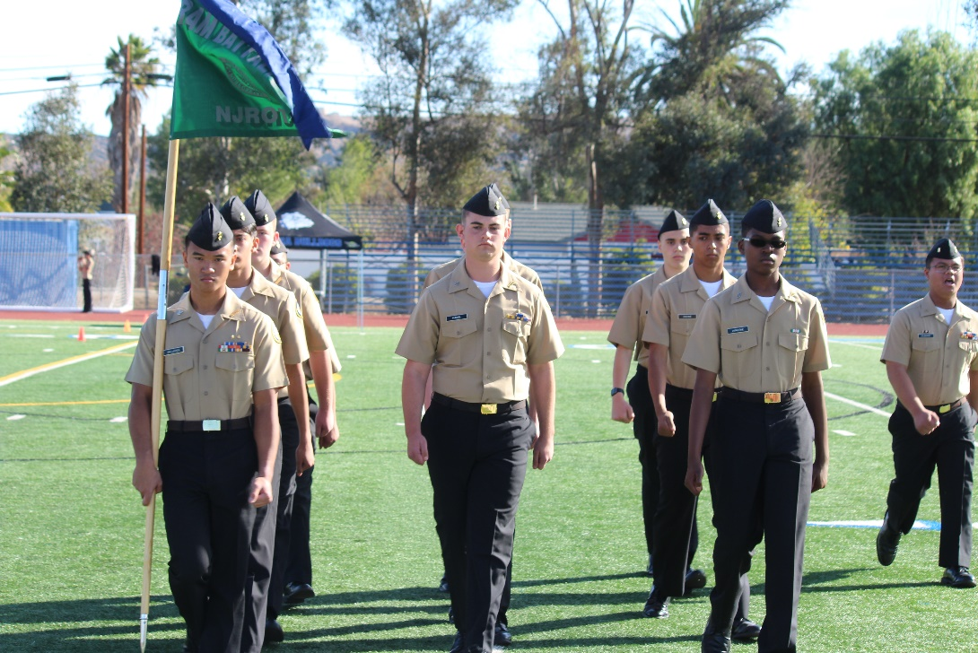Led by Oliquiano (Unarmed Regulation commander).

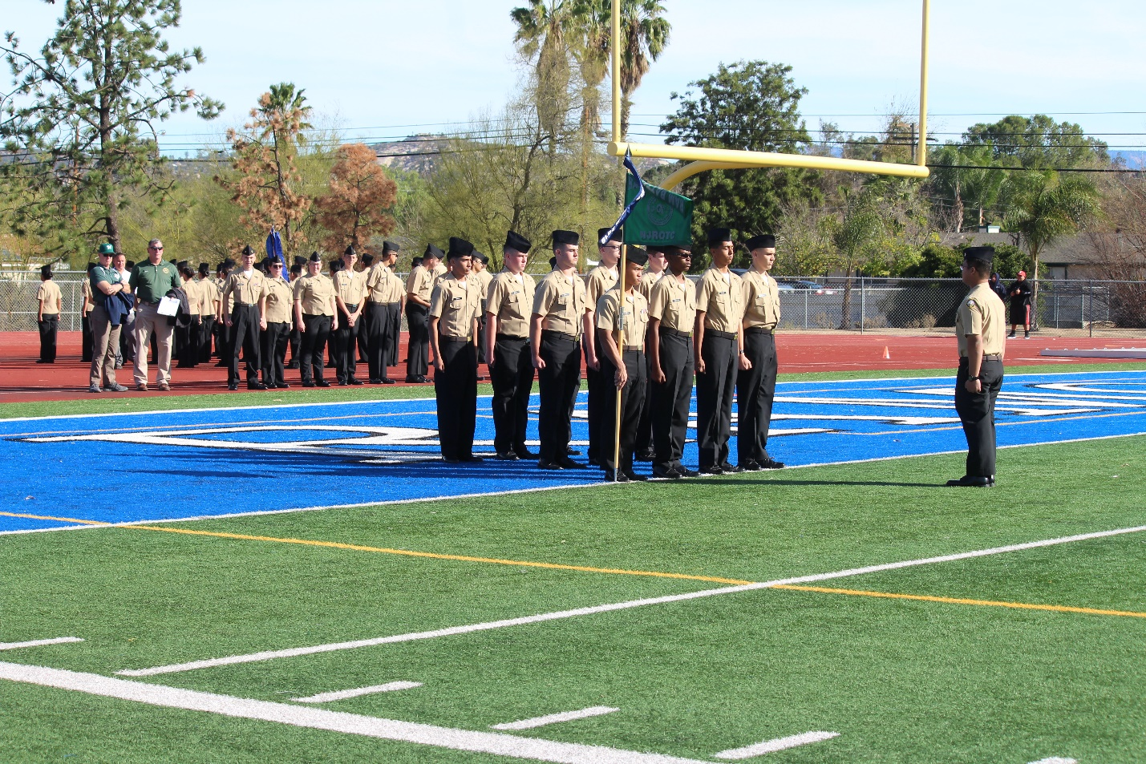

Unarmed Exhibition led by Jake Carpenter.

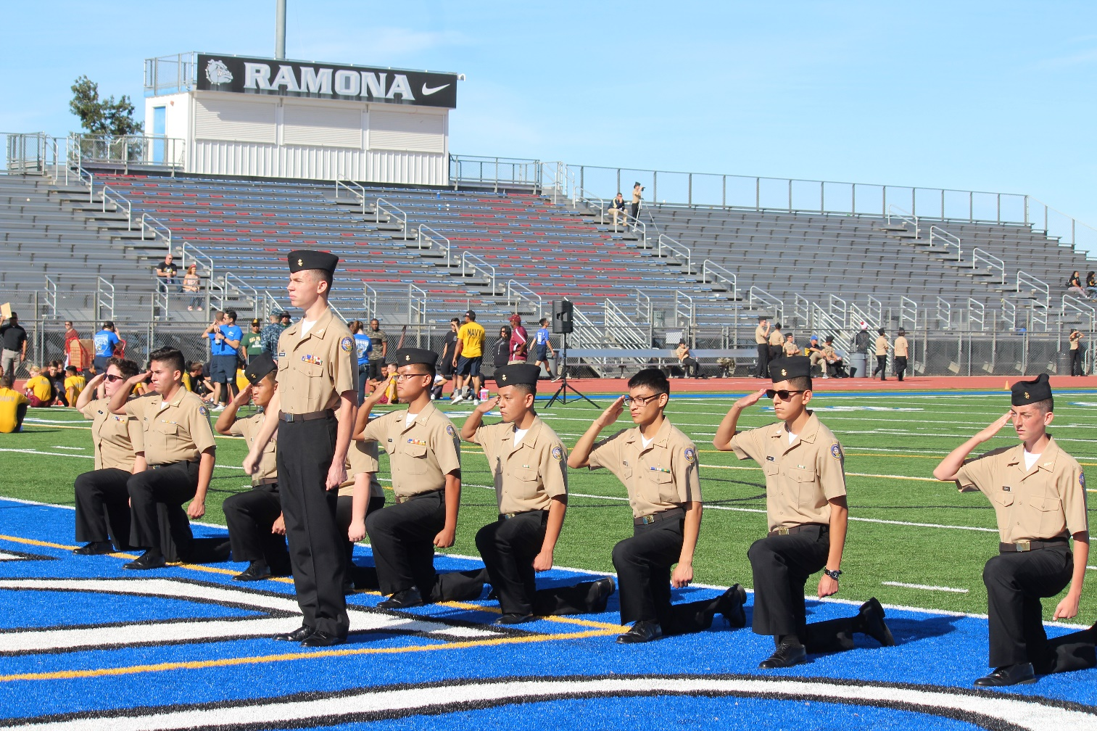

After the Exhibition commander had time to reflect on his performance and his team, he had plenty to say. *“The team did alright, the good news is that we are exactly where Chief, and Colonel wants us. Within the first thirty seconds of the routine, half the cadets lost their covers and didn’t even flinch! I was happy about that nonetheless. The alignment and space awareness from everyone on the team was exceptional. We stood out because everyone on the team was very loud when it came to shouts, slapping, clapping, and stomping (which is good in exhibition). I would have to say that the alignment, as well as the lack of reaction to covers being blown away while doing the routine made me the proudest.”*

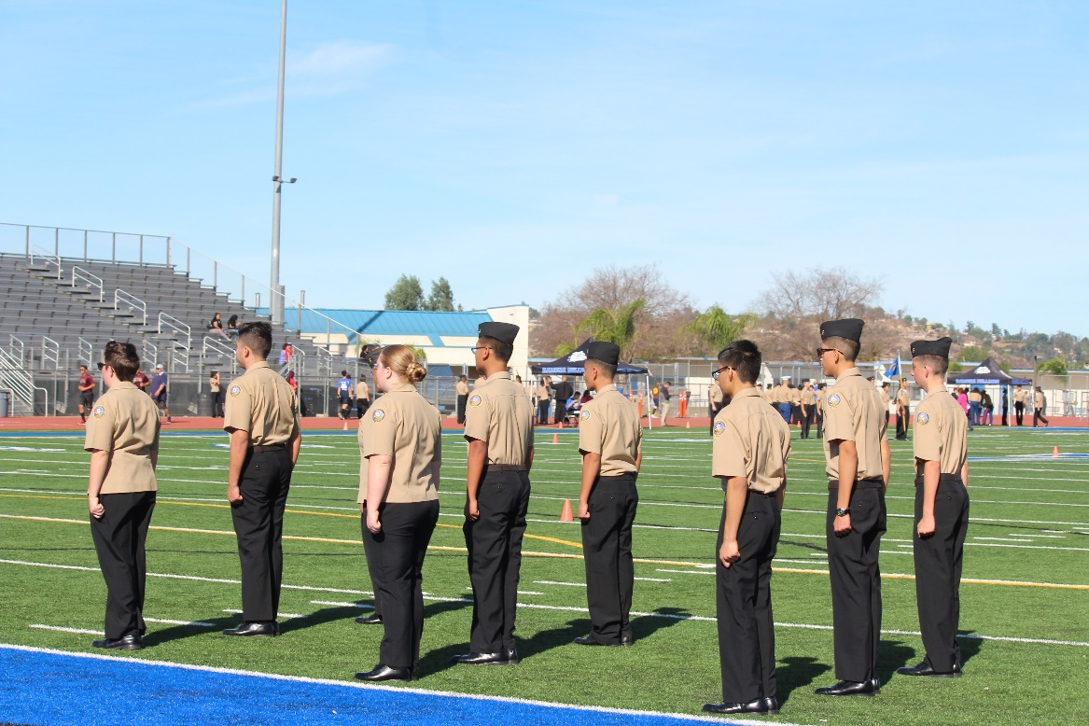

Led by Carpenter.

Question: What do you think made Chief and Colonel proud?

Carpenter: “*What made Chief and Colonel proud, was the fact that the routine is exactly where we need it to be and, that everyone was aligned.”*

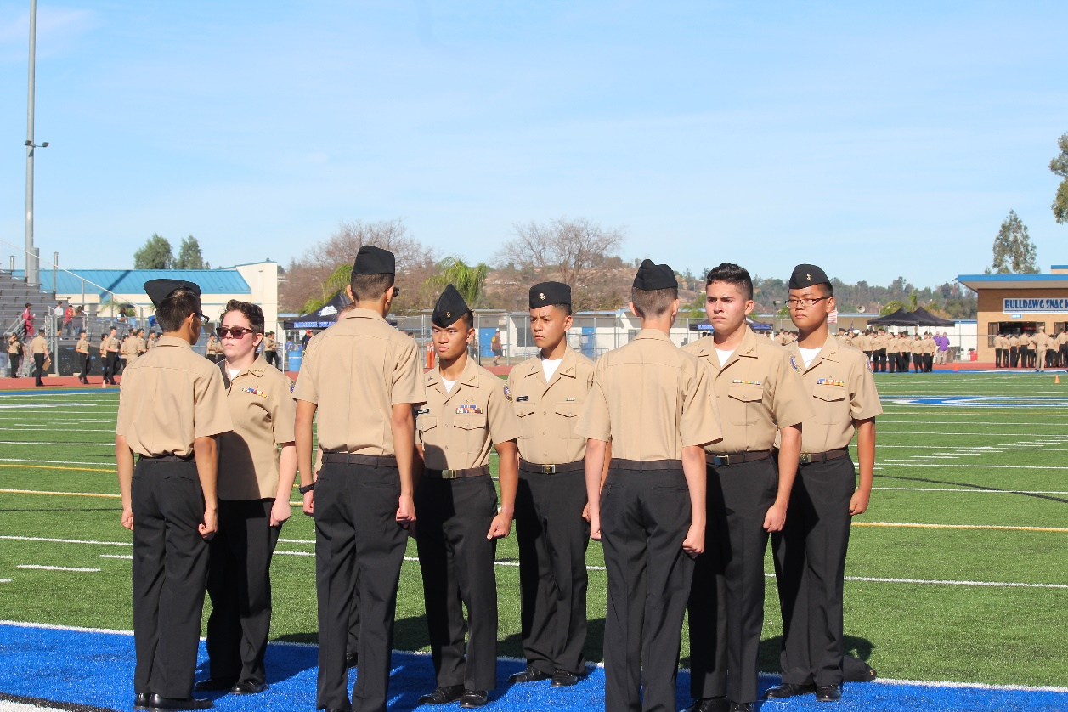

Armed Regulation placed 14th – Lee.

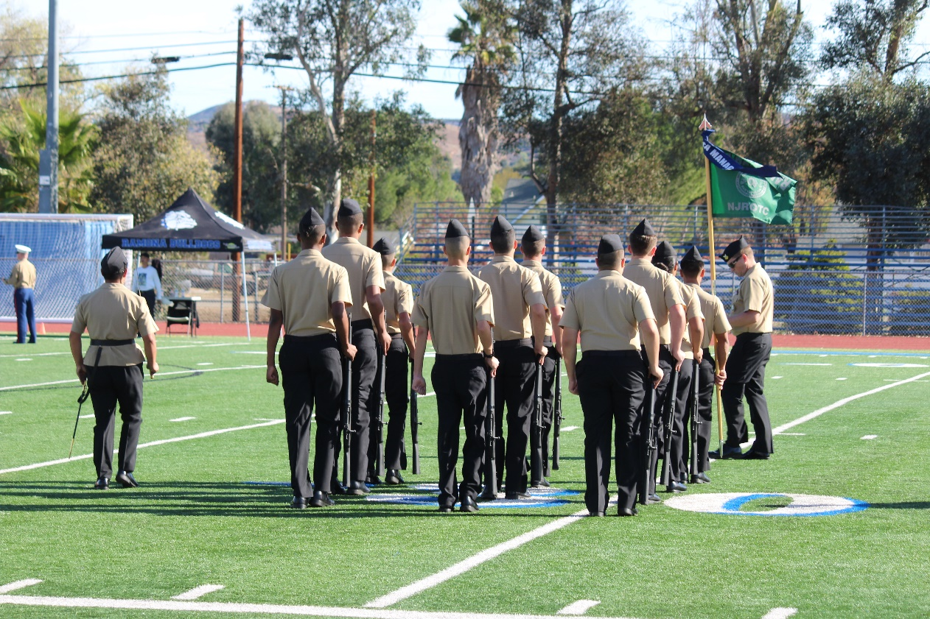

Armed Exhibition placed 10th – Lee.

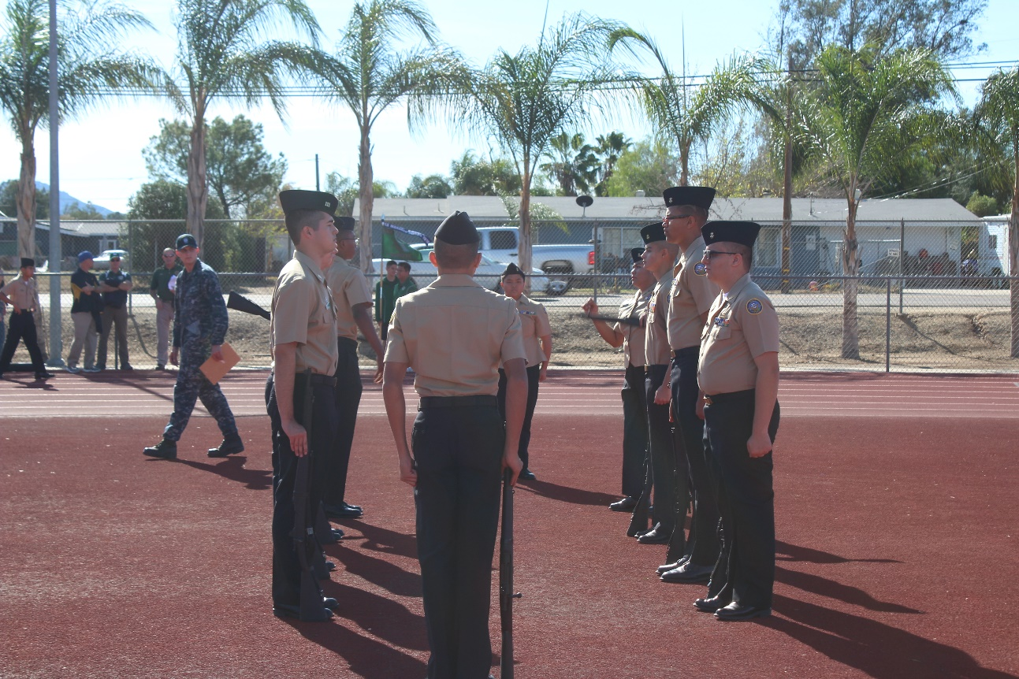Cadets in picture (not in order): Led by Lee(commander), Vicencio, Bryles, Bannister, Hanna, Vasquez, Valderama, LaFontaine, Backlund, Bailes, Galleros.

Lee, commander of both regulation and exhibition, states how proud she is of both performances. *“I would say my team did really well, we did make a few mistakes but, we all pulled through as a team. I would love to highlight the whole team. They all represented NJROTC’s core values, which is honor, courage, and commitment. I am very proud of how hard they worked and how far they’ve come. What went well with the team was bearing. I would say that our degree of difficulty made the team stand out from others, as our routine is very complex and, took weeks to be close to perfect! What moment made me the proudest was seeing how determined my cadets were and, seeing them give 110 percent to everything that they did.”*

Question: What do you think made Chief and Colonel proud?

Lee: *“I believe that their commitment made Chief and Colonel proud the most, because all of them showed up to represent our program and, the team.”*

*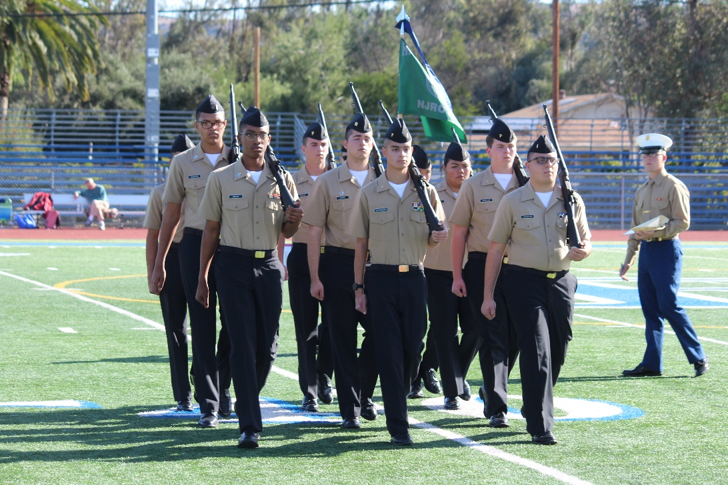*

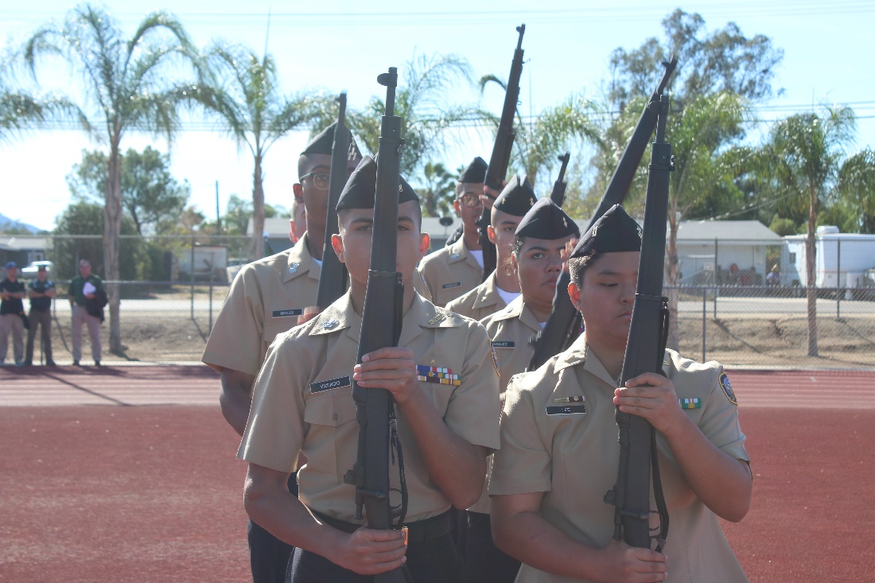

PT events:

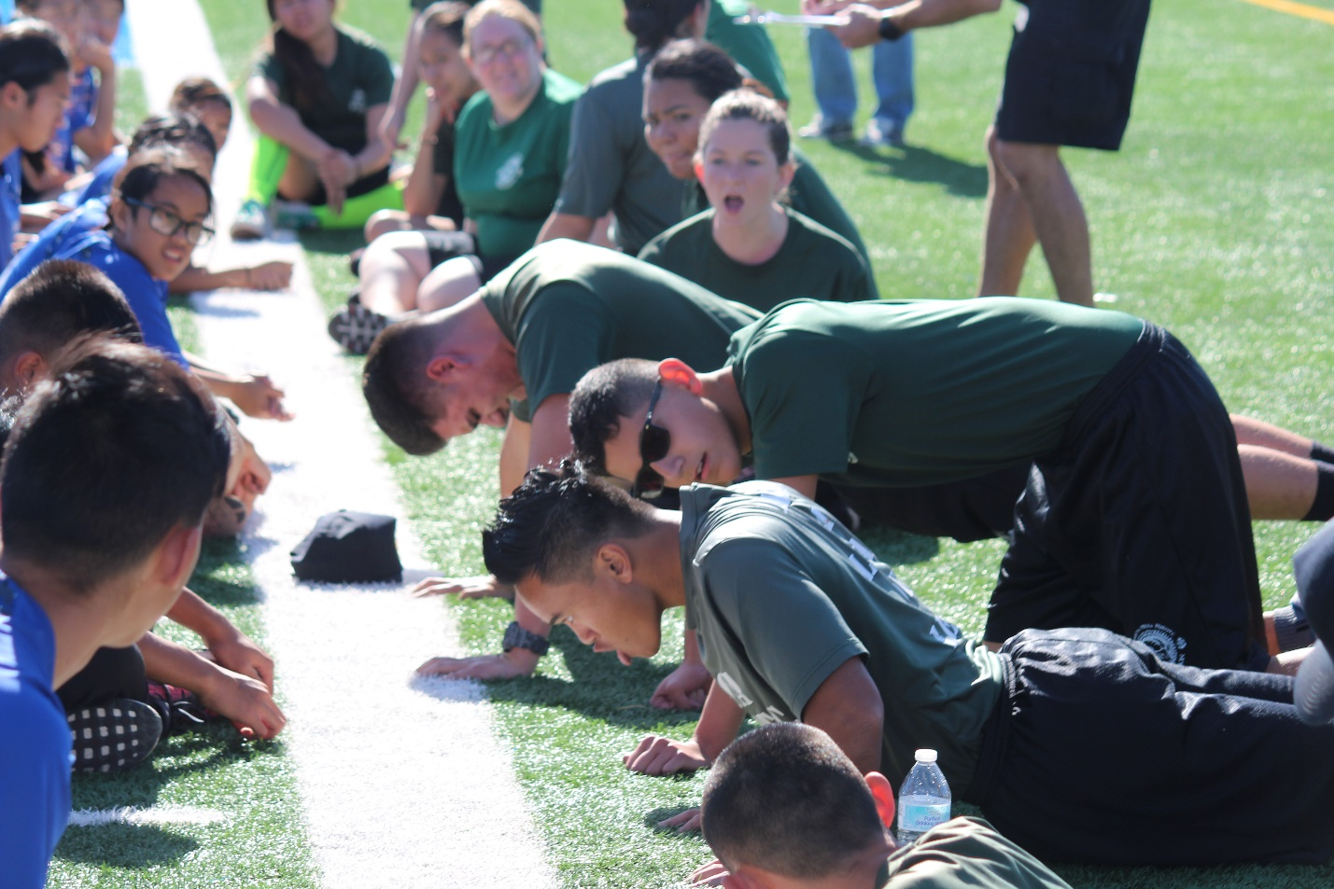Sjobeck: *“During pushups, Galleros was pushing hard to do as many as possible.*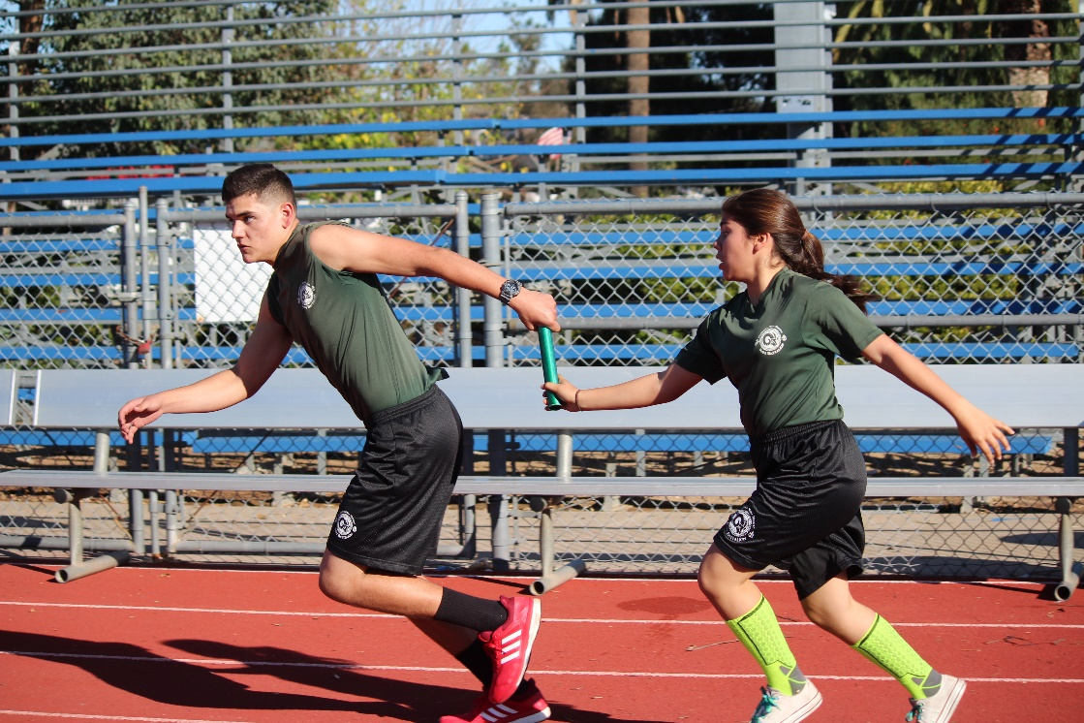*”*

In picture above (taken by Sjobeck): Derick Galleros, Xavier Rose, Esvin Lopez.

In picture to the left (taken by Sjobeck): Savanna Carrera, Xavier Rose.

At the drill meet, fellow Public Affairs assistant, Madison Sjobeck, interviewed Chief and Colonel on their views of the drill meet. They gave great insight and motivated our teams by talking about them positively:   
Question: How do the drill teams look as a whole?

Chief: *“They look good! We still have little ways to go to be completely competitive and ready for the*

*Super bowl, but they are looking great at this time.”*

Colonel: *“Given that we’re not even back from Christmas break, we did very well and once again, our purpose for this drill meet was to get prepared for the Paloma Valley High School(meet), so this is a dress rehearsal for that. But we look pretty good.”*

Question: What are your highlights of each team?

Chief: *“For color guard, their sharpness and their ability to stayed aligned. They actually did very well with that.”*

Question: Any cadet you would like to highlight specifically?

Chief: *“Oliquiano. He did great commanding the unarmed drill team. Every single instructor commented on how well he sounded off and led his team.”*

Colonel: *“All of the drill team commanders did excellent and are very dedicated. My hats off to all the commanders who make this stuff happen.”*

Question: What made this drill meet significant?

Chief: *“This is the most competitive that we’ve ever looked. So, this is the most prepared we’ve been for any drill meet. This just shows that the progress our drill teams have made in the last year.”*

Colonel: *“It is a beautiful day and we had 40 cadets show up.”*

Question: How does this reflect on our program?

Chief: *“Amazing! There are people higher up in the NJROTC chain who see our program into the right direction, which is going to help us get funded and become a better program.”*

Colonel: *“It reflects very positively on our program. We’re doing this level of drill meets, we’re doing well on them. That is one of the things the Chief and I wanted to make sure our drill teams are solid this year and they are, so we have met that mission and we’ll just get better in the future.”*

Question: Is there anything you want out of the cadets on the teams?

*Chief: “More commitment. If they were at every practice, I would be happy.”*